**CFARS Site Suitability Initiative:**

**A Comparison of Cup Anemometer and Remote Sensing Device Turbulence Intensity for the Acceleration of Data-Driven Guidance on RSD Derived Turbulence Intensity**

***Authors:***

Alexandra St. Pé (RWE Renewables), Alexandra E. Arntsen (NRG Systems), Ellie Weyer (UL), Iain Campbell (RES), Zach Parker (Nordex), Nigel Swytink-Binnema (Nergica), Nicolas Jolin (Nergica),   
Barrett T. Goudeau (NRG Systems), René Meklenborg Miltersen Slot (EMD), Joseph C. Y. Lee (NREL), Mithu Debnath (NREL), Scott Wylie (ZXLidars), Dale Apgar (GE), Thomas Fric (GE), Dan Michaud (GE), Elizabeth Smith (RES), Paul Mazoyer (Leosphere), Marcel Mibus (APEX), Philippe Pontbriand (TransAlta), Mackenzie Tocco (Avangrid), Fabrice Guillemin (IFPEN), Krystina Teoh (EDPR)

Executive Summary

As an organisation, CFARS exists to advance the acceptance of remote sensing devices (RSD) in the wind industry and to aid the deployment of RSDs in greater numbers, in more varied flow conditions, and for a wider variety of valid use cases, than is currently standard.

There are many benefits of RSDs underpinning the desire for greater use of RSD for wind industry applications, including safety, cost, efficiency and the capacity to measure more complex boundary layer parameters (e.g., Turbulence Kinetic Energy etc.).

As an industry we strive for improved safety in all that we do. We know that substituting masts with RSDs leads to fewer accidents and near misses [citation P Stuart WindEurope]. Further, it is widely viewed that if an RSD satisfies the technical requirements of a use case, it should be used in lieu of meteorological masts.

Therefore, as we seek to deploy RSDs in increasing numbers in more complex flow conditions and for a wider variety of use cases, it is important that the measurements obtained from these devices are well understood and appropriate for the intended purpose(s).

One key use case for wind data is that of site suitability analysis, determining the most optimal turbine for the given site conditions. One of the key variables in any site suitability analysis is turbulence intensity.

Today, a majority of the industry’s understanding of, and therefore tools for modeling the effect of, the relationship between turbulence conditions and turbine fatigue loads are derived from cup anemometer measurements on meteorological masts. It is well known that RSD turbulence intensity measurements differ from cup anemometers given inherent differences in measurement principles. Therefore, until the industry improves understanding of the relationship between RSD derived turbulence intensity and turbine fatigue loads directly, RSD measurements should be adjusted to produce similar results to anemometers, to avoid installation of potentially suboptimal turbines for the given site conditions.

Ideally, a TI adjustment methodology would be developed that permits the use of RSDs, not only in conjunction with an onsite meteorological mast, but also in the absence of any supplemental onsite measurements. The CFARS Site Suitability subgroup formed with the **mission to frame the discussion on how best to increase confidence in the use of ground based, vertically profiling, RSDs for onshore site suitability assessments and to build consensus on RSD use, both as a collocated and a standalone[1] device.**

The Site Suitability subgroup has adopted an open and novel R&D framework to achieve its mission and to support the industry’s desire for alignment on best practice guidance to resolve the inherent differences between cup anemometers and onshore, single-profiling, ground-based, RSD TI measurements. The R&D framework consists of three separate phases of work (referred to as the three pillars), each founded with the objective to provide data-driven answers to persistent RSD TI measurement questions.

In this white paper, results from Pillar One of this framework are presented. Specifically, the results of the Subgroup’s benchmarking activity quantifying the differences between turbulence intensity (TI) measurements from RSDs and cup anemometers (on meteorological masts) are reported in detail. In addition, the Subgroup’s ongoing work to extend the benchmarking activity to include the impact of disparate adjusted TI input on a generic turbine fatigue load model output is described. These efforts have been made possible by the creation of an opensource TI adjustment tool, which processes project data for in depth analysis and enables testing of over a dozen global and site-specific turbulence intensity adjustments.

Finally, this white paper proposes an evaluation framework to link the TI benchmarking activities to turbine site suitability decision-making (Figure 2). The goal of the evaluation framework is to introduce a pathway by which the appropriateness, or acceptance, of RSD TI measurements for turbine suitability may be determined. This concept encourages wind developers and turbine OEMs to understand the sensitivity of the turbine fatigue load model output to the input TI measurements, and therefore contributes to increased understanding of risks when accepting RSD TI measurements for site suitability assessment. Ultimately, if these goals are achieved, the work of this subgroup allows for better-informed decisions on acceptance.

Contents

1 Who is CFARS? 5

2 RSDs & Site Suitability – Mission, Motivation, Challenge, & Scope 6

3 R&D Framework 8

4 Pillar 1: Benchmarking TI Measurement Differences 11

4.1 Impact of Differences in Turbulence Intensity Measurement 11

4.2 Data & Analysis Approach 11

4.3 Methods & Metrics 12

4.3.1 Mean Bias Error (Accuracy) and Root Mean Square Error (Precision) 14

4.3.2 Representative TI 18

4.4 Benchmarking Results 20

4.4.1 Aggregated TI MBE 20

4.4.2 Aggregated TI RMSE 23

4.4.3 Representative TI 25

4.5 Conclusions & Next Steps, Further Work… 27

5 References 28

Appendix 1 29

# Who is CFARS?

A pressing question in the wind industry remains - how can we reduce the cost of wind energy and de-risk future projects? In 2017 an industry consortium, the Consortium for Advancing Remote Sensing (CFARS), launched to take on this cardinal question, focusing on remote sensing devices (RSDs) as a viable solution to reduce costs and risk in the realm of pre-construction wind resource assessment.

CFARS is comprised of nearly 30 diverse wind energy stakeholders, including developers, consultants, turbine manufacturers, RSD manufacturers, and research institutions. The mission of CFARS is to **increase acceptance of RSDs in the wind industry**.

CFARS **provides an opportunity for key wind stakeholders to collaborate** on projects that advance the understanding of the accuracy and reliability of RSD measurements while removing the nuance and ambiguity in RSD best practice methods for the full life cycle of wind project development.



**CFARS**

**C**onsortium **F**or **A**dvancing **R**emote **S**ensing



# RSDs & Site Suitability – Mission, Motivation, Challenge, & Scope

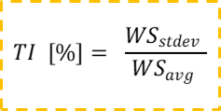Within CFARS, the Site Suitability subgroup aims to increase the acceptance of RSDs for turbine site suitability assessment. The subgroup is focused on turbulence intensity (TI) measurements by wind speed, describing how much the wind speed at a given height varies over a 10-minute period for a given wind speed bin.

High turbulence can generate excessive fatigue loads on major components in a turbine. This is a problem because it reduces turbine performance and energy yield, increases operation and maintenance costs related to unanticipated repairs, and potentially decreases the turbine’s overall lifespan. Therefore, it is imperative that a project site’s TI conditions during a pre-construction site suitability assessment are accurately measured and understood to make sure we are choosing a suitable turbine — a turbine that will not endure disproportionate fatigue loads once operational. Reliable measurements of TI are required, not only for selecting an appropriate turbine, but also to enable site suitability modeling to ensure an appropriate operating strategy for the selected turbine. This is increasingly pertinent as the industry seeks to extend and maximise turbine lifetimes.

Today, a majority of the industry’s understanding, methodology, and modeling for turbine site suitability assessment originate from cup anemometer wind speed measurements on meteorological masts. While trusted cup anemometry remains invaluable, the familiarity and reliance on cup anemometry have been barriers to wide-spread use of RSDs. However, the growing demand to meet new market requirements, coupled with more than a decade of proven RSD wind measurements, is motivating broad industry desire and momentum towards integrating more agile and advanced measurement techniques from RSDs into many elements of wind project development and operation, including site suitability assessment.

In particular, turbine hub heights are ever increasing, which also increases the costs (sometimes prohibitively) to install and maintain near hub height meteorological masts. RSDs are proven devices that can reliably and accurately [reference] make measurements for these high hub heights and also at additional heights across the whole turbine rotor.

Another important industry motivation is that of safety. Safety is critical to our industry. It should no longer be acceptable to use a higher risk method of wind measurements (meteorological mast) as standard, when a safer, lower risk, method (RSD) can also give technically acceptable results.

Specifically, in relation to site suitability, there are a number of relevant considerations for turbine safety, and certification:

1. Wind turbines are often operated close to the site-specific conditions. Thus, uncertainty and bias originating from a site suitability analysis based on RSD TI measurements could lead inadvertently to the breaching of fatigue load design limits of a WTG and thus component damage and increased failure rates, jeopardising the WTG’s structural integrity and thus resulting in safety issues.
2. Turbines are developed, designed and verified (prototype wind and load measurements) against anemometer turbulence intensity and the loads calculated based upon these turbulence measurements. Any change in measurement technology and differences in turbulence intensity could lead to a ‘misalignment’ or bias in the design load calculations which are the basis for a turbine certification.
3. There could be a misalignment in turbulence intensity assumptions on a project level. Turbines are designed and certified against anemometer TI. If, as part of a wind farm certification or due diligence, on-site RSD TI data are being used, the TI prediction method needs to be sufficiently precise to produce a TI level comparable with the measurement technology (anemometers) used in the actual design of the turbine.

Therefore, while it is currently not broadly accepted to deploy standalone RSD for all sites or for all measurement purposes, the mission of CFARS remains: to increase the acceptance of RSDs, by demonstrating their validity across the full life cycle of wind project development and specifically, in the case of this whitepaper, for site suitability.

Nonetheless, two compounding challenges lie ahead on the road to RSD derived turbine site suitability decisions. The first challenge is the fundamental difference between cup anemometer and RSD wind measurement principles. The RSD measures across a *volume of air* (assuming homogenous flow through this measurement volume and can therefore be adversely affected by complex flows), while cups measure at a single point. Although both cup anemometers and RSDs are influenced by vertical wind speed, an RSD can isolate this component from the TI measurement, while a cup anemometer cannot decompose velocity vectors. As a result, cup anemometer and RSD TI measurements vary even when collocated. Therefore, while both cup anemometer and RSDs indicate TI, the measured turbulence fundamentally differs hence the direct comparison between the two observations requires more care.

The second, perhaps more formidable challenge, is centered on *what we do as an industry about the inherent cup to RSD measurement differences*. The CFARS Site Suitability subgroup formed with the **mission to frame the discussion on how best to increase confidence in the use of ground based, vertical profiling, RSD for onshore site suitability assessments and build consensus on RSD use, both as a collocated and a standalone[2] device.**

While the use and relevance of accurate TI measurements (and therefore the correct relationship between RSD and cup TI measurements) is not limited only to site suitability and turbine loads models, the scope of this whitepaper is narrow and focused solely on increasing the acceptance of RSDs for turbine site suitability assessment[3]. This whitepaper does not address the impact of TI on AEP estimates, nor does it consider RSD measurements for power performance.

# R&D Framework

The Site Suitability subgroup has established an open and novel R&D framework to achieve its mission and to support the industry’s desire for alignment on best practice guidance to resolve the inherent differences between cup anemometers and onshore, single-profiling, ground-based, RSD TI measurements. The site suitability R&D framework consists of three pillars, each founded with the objective to provide data-driven answers to persistent RSD measurement questions.

Pillar 1 of the framework is a benchmarking exercise, which measures the magnitude of TI measurement differences between a reference cup and a redundant cup as well as between an RSD and a reference cup within a collocated, concurrent, dataset for several independent projects. While previous studies have highlighted inconsistencies in measurements between cups from varying manufacturers [ref inflow/stability response of cups], the CFARS stakeholders agreed there is value in performing the first industry-wide round-robin evaluation of inherent cup-to-cup measurement discrepancies aimed at elucidating how the cup-to-cup discrepancies compare to the magnitude of discrepancy between cup anemometer measurements and RSD measurements both unadjusted and adjusted. Several RSD TI adjustment methods, including site-specific and global configurations, are tested in this benchmarking activity.

Pillar 2 benchmarks the sensitivity of various TI measurements on turbine fatigue loading, using a generic loads model and the NREL 5MW reference turbine. This benchmarking measures load model differences based on changing the TI input data only; using data from the reference cup, the redundant cup, unadjusted RSD measurements and adjusted RSD measurements.

Pillars 1 and 2 are enabled by the development of the CFARS Site Suitability Subgroup’s TI Adjustment Tool. The tool has been designed to process each project dataset in a standardized fashion to extract summary statistics of head-to-head measurement comparisons as well as perform analysis that tests the sensitivity of measurement discrepancies to measurement conditions, length and timing of model generation periods, and other observational data and metadata used to categorize the projects. Furthermore, the tool enables the implementation of various adjustment techniques and variations of those techniques to inform performance analysis with a large amount of data. A particularly novel advantage to this approach is the tool’s ability to create a new aggregation of observations from various projects to assess how global models created from diverse and numerous datasets compare to those generated and implemented at a single location.

Pillar 3 establishes a direct link between the benchmarking activities in pillar one and two and the potential downstream risk considerations that may influence turbine site suitability decision-making (Figure 2) when using adjusted RSD TI. The goal of the evaluation framework in this pillar is to introduce a pathway by which the appropriateness, or acceptance, of RSD TI measurements for turbine suitability may be determined. This concept encourages wind developers and turbine original equipment manufacturers (OEMs) to understand the sensitivity of the turbine fatigue load model output to the input TI measurements, and therefore contributes to increased understanding of risks when accepting RSD TI measurements for site suitability assessment. Ultimately, if these goals are achieved, the work of this subgroup allows for better-informed decisions on acceptance. It is well known that stakeholders can potentially save time and money through widespread deployment of RSDs in measurement campaigns and this pillar has been developed with the goal of directly progressing the acceleration of widespread adoption of RSDs for suitability assessment at appropriate sites.

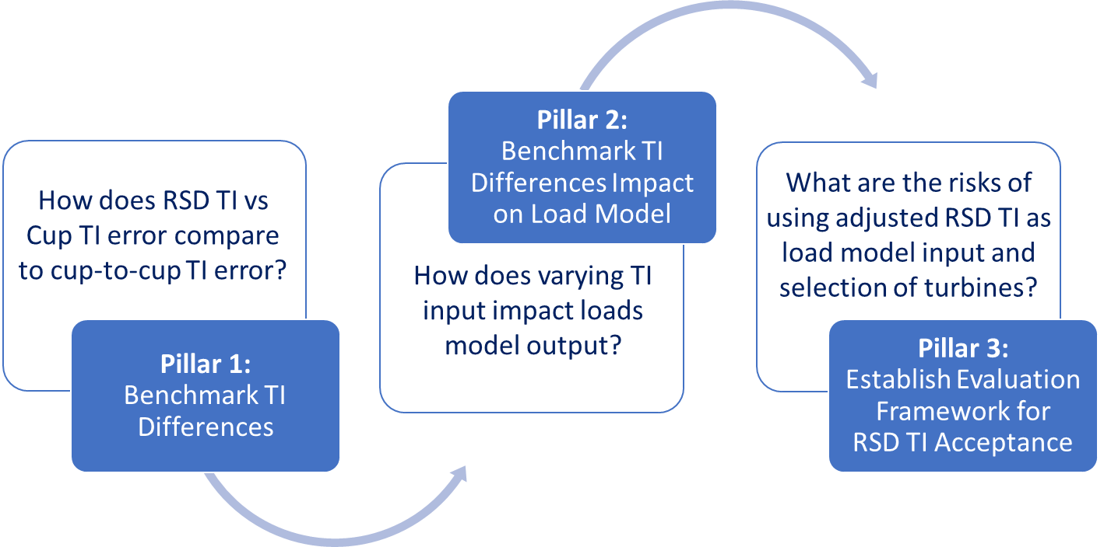

*Figure 1 The Site Suitability Subgroup’s Research Framework organized in three phases (pillars) motivated by three industry impactful research questions.*

Adjustment methods applied to the remote sensing TI data should be based on evidence from collocated remote sensing and anemometer deployments in similar terrain conditions and should address representative TI as well as mean TI (both defined in following sections). As wind turbines are certified against cup anemometers (and not RSDs), the party employing any such adjustment technique is required to present evidence that the specific RSD and its measurements, at the site in question, meet a set of defined acceptance criteria[4]. Only then are other stakeholders (such as wind turbine OEMs and certification bodies) able to use such data for their individual purposes.

The CFARS Site Suitability subgroup does not endorse or recommend any RSD, nor any particular adjustment method. Rather, the Site Suitability subgroup hopes the evaluation framework and results presented herein further initiate open, thought-provoking discussions and illuminate one viable path to frame future decisions on RSD acceptability for site suitability assessment. With this white paper we are seeking to establish an evaluation framework that defines the following:

1. The important parameter(s) that should be considered
2. The relevant statistical analysis for comparing each parameter
3. Appropriate evaluation metrics and criteria to define the target for RSD data validity
4. A load-based approach which could be used more precisely stakeholders to consider and decide on acceptability of load bias and uncertainty in specific cases

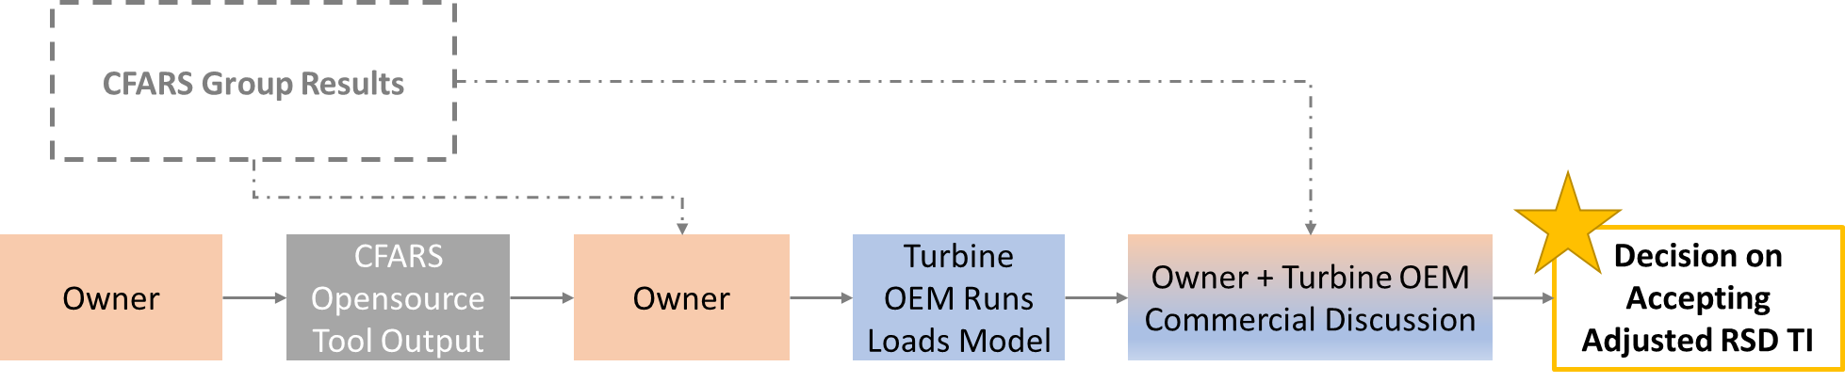

Figure 2 Schematic representing the proposed interaction between the CFARS Site Suitability Subgroup output and stakeholders leading to more informed acceptance decisions. The goal is to enable owners to gain valuable insight about their projects using the subgroup’s output ahead of engagement with Turbine OEMs and Independent Engineers.

Finally, this CFARS stakeholder group continues to work closely with other industry working groups, such as the IEA Task 32 and also with related RSD TI working groups to ensure the learnings amongst all entities are shared and that maximum value is generated towards the common objective to advance understanding of RSD use for site suitability.

The structure and motivation of all three pillars is outlined above in order to contextualize the larger objectives planned for the work presented in this white paper. The sections following present the details of the Pillar 1 benchmarking analysis and results only, a body of work designed to act as a part 1 of 2 planned publications documenting the subgroup’s overall achievements within this research initiative.

# Pillar 1: Benchmarking TI Measurement Differences

## Impact of Differences in Turbulence Intensity Measurement

The difference in turbulence intensity measurements between two sensors or two discrete representations of TI (i.e. adjusted vs. unadjusted) manifests as a difference in the characterization of turbulence intensity mean and standard deviation in each windspeed bin at a given project site. Because a loads model ingests these binned statistics, the model output from two different TI distributions as input will vary based on the magnitude of bias between the two TI distributions in each bin. It is also important to note that differences in TI within each wind speed bin can impact loads differently depending on both the project site and specific turbine model. Therefore, the definitive acceptance of TI measurements relies on an evaluation based on a specific turbine model and the statistical representation of the TI distribution coupled with the site wind speed distribution as input to a specific load model. For example: For one turbine, a relatively high TI bias in a low wind speed bin may lead to a higher error in the overall loads than another turbine with a lower percentage of overall power production in that wind speed bin.

## Data & Analysis Approach

To benchmark the TI differences, 35 datasets were collected from 8 organisations. Of these 35 datasets, 29 consisted of 10-minute data from two anemometers and an RSD measurement, all collocated at the same height. The remaining 6 datasets had data from two anemometers only. Each organisation filtered their own datasets for RSD measurement quality, sensor plausibility, icing, and met tower shading.

The CFARS Site Suitability subgroup created an opensource tool [Citation], which was then used by each organisation to locally process their own filtered datasets. The tool was designed to calculate the desired summary statistics with a consistent analysis methodology and format. The subgroup then collected, compiled, and analysed the aggregated results.

The group datasets include:

* 4 anemometer types, 2 lidar types, and 1 sodar
* Concurrent measurement heights ranging from 30 m to 139 m
* Met tower to RSD collocation distances ranging from 0 m to 130 m
* Simple, moderate, and complex terrain classes[5]
* 8 regions in North America and 3 locations in Europe
* Lidar and sodar measurements directly output from the device (i.e., no post-processed adjustment methods applied)

Since the CFARS Site Suitability subgroup began, the analysis approach has been iterative as the group learning and stakeholder input has evolved.

## Methods & Metrics

The methodologies and metrics used in the benchmarking tests for all 35 project datasets are described in this section with reference to and the plotting of an example dataset (“the example dataset”) for illustrative purposes. The example dataset contains wind speed measurements from 2 cup anemometers and 1 RSD at the same measurement height and concurrent in time. The example dataset is comprised of filtered 10-minute data over a period of 4 months. This dataset has 10 channels as shown in Figure 3 below. The first cup anemometer in each dataset, as in this example dataset, is defined as the reference anemometer, i.e. the truth measurement (WS_Cup1_Avg). Each wind speed measurement source (Cup1, Cup2, RSD) has an associated attribute for wind speed average, wind speed standard deviation, and calculated TI as depicted in the column header in Figure 3.

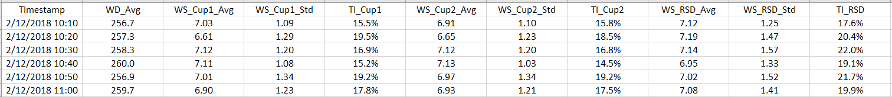

Figure 3 Timeseries Subset of the Example Dataset

The TI for each 10-minute timestamp is calculated by

|  |  |
| --- | --- |
|  | (1) |

where TI is expressed as a percent, its most common form.

Figure 4 provides a common visualisation of the example data, showing TI from the three measurements as a function of the reference wind speed (Cup1).

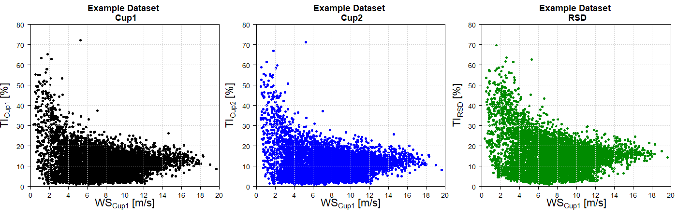

Figure 4 Scatter plot of TI Data for the Example Dataset

More informative however, is the direct *comparison of various TI measurements*. The simplest metric for this comparison is **TI difference**. The reference wind speed (Cup1) is considered our baseline, so using the data shown in Figure 4, we can calculate the difference between TI observed by Cup2 and by Cup 1 (TICup2 - TICup1, labeled “Cup2Cup”) and the difference between TI observed by the RSD and by Cup 1 (TIRSD - TICup1, labeled “RSD2Cup”) for every 10-minute timestamp.

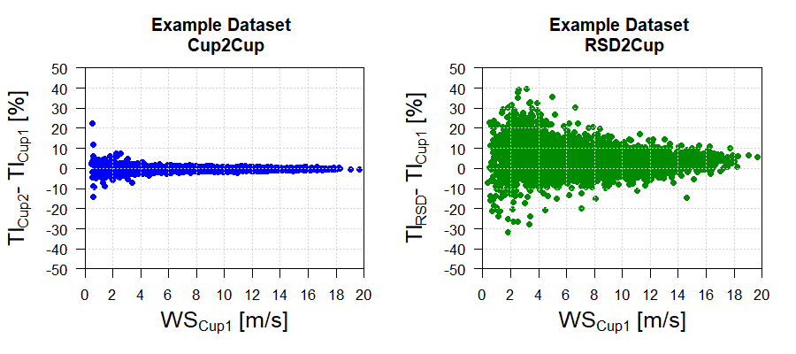

Figure 5 Scatter plot of TI Difference for the Example Dataset

From Figure 5 it is evident that for this example dataset, the RSD2Cup TI differences are greater than the Cup2Cup differences with RSD2Cup comparison results showing a more pronounced deviation from zero within each wind speed bin; nonetheless both sets of TI differences are non-zero, although the mean TI difference across all wind speed bins is consistently positive for RSD2Cup comparison (3.2 %) and closer to zero for the Cup2Cup comparison (-0.2 %). Pillar 2 and Pillar 3 of the CFARS research initiative will quantify how much TI difference is significant in the context of site suitability decisions and will evaluate different RSD TI adjustment methods to reduce TI differences across all wind speed bins.

### Mean Bias Error (Accuracy) and Root Mean Square Error (Precision)

The CFARS Site Suitability Subgroup chose two basic statistical metrics to quantify the differences between concurrent and collocated TI measurements.

First, **TI Mean Bias Error** (MBE) is used to measure the *average TI difference between two datasets*, which gives overall bias or systematic error. When using MBE, the error direction, indicating an over prediction versus an underprediction, is preserved but muted in the process of averaging. MBE can be described as a measure of *accuracy* (i.e. representative of closeness to the truth). Figure 6a shows an example of high accuracy results (i.e., MBE close to 0) and 6b shows an example of low accuracy results (i.e., MBE farther from 0), despite both panels having the same precision (spread of the observed data).

|  |  |
| --- | --- |
| *truth*  Figure 5a Higher Accuracy = Mean is close to truth  *(i.e., MBE close to 0)* | *truth*  Figure 5b Lower Accuracy = Mean is farther from truth  *(i.e., MBE far from 0)* |

The equation for MBE is shown below. In this analysis, a value of zero for MBE at a given wind speed bin indicates that on average, the two TI measurements are indistinguishable. Oftentimes, MBE is a single number, though due to the importance of resolving the results of this analysis by wind speed bin, TI MBE is calculated for each wind speed bin i such that:

|  |  |
| --- | --- |
|  | (2) |

where,

TIcomp is the comparison quantity (TICup2 or TIRSD)

TIref is the reference quantity (TICup1)

i is the wind speed bin

n is the individual datapoint (timestamp)

N is the total number of data points in wind speed bin i

Next, the **TI Root Mean Square Error (RMSE)** is used in this study to measure the *average TI precision* between two datasets, where the direction of the error is not considered. Strictly speaking, precision refers to the repeatability of data measurement. Herein, because in a broad scale, we are comparing datasets with different methodologies under different measurement conditions, precision in this study represents the random error or the statistical variability between instruments, which can be described by the spread of the TI errors (i.e., RMSE). Figure 6a shows an example of high precision (i.e., low RMSE) and Figure 6b shows an example of low precision (i.e., high RMSE), despite both figures illustrating the same average accuracy.

|  |  |
| --- | --- |
| truth  Figure 6a Higher Precision = Lower Spread  *(i.e., lower RMSE)* | truth  Figure 6b Lower Precision = Higher Spread  *(i.e., higher RMSE)* |

The equation for TI RMSE is shown below, where we calculate TI RMSE for every wind speed bin i following:

|  |  |
| --- | --- |
|  | (3) |

Considering again the example dataset, **TI MBE** is calculated by binning the data from the scatter plot shown in Figure 4. Figure 7 below shows the TI MBE for the Cup2Cup and for the RSD2Cup comparisons. Recall that Cup1 is always considered the reference measurement in this study, and either Cup2, lidar, or sodar are the comparison measurement. Figure 7 shows TI MBE results for the example dataset, demonstrating higher accuracy for the Cup2Cup results (near-zero MBE) compared to RSD2Cup results (larger MBE, further from zero ). It is also worth noting that the RSD2Cup MBE in the Figure 7 example is positive across all wind speeds, meaning there is a consistent overestimation in TI bias compared to the reference cup.

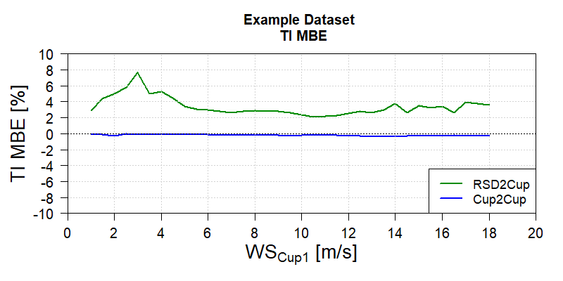

Figure 7 TI Mean Bias Error (MBE) for the Example Dataset

Figure 8 below shows the **TI RMSE** results for the example dataset, illustrating higher precision for the Cup2Cup results (lower RMSE) compared to RSD2Cup (higher RMSE).

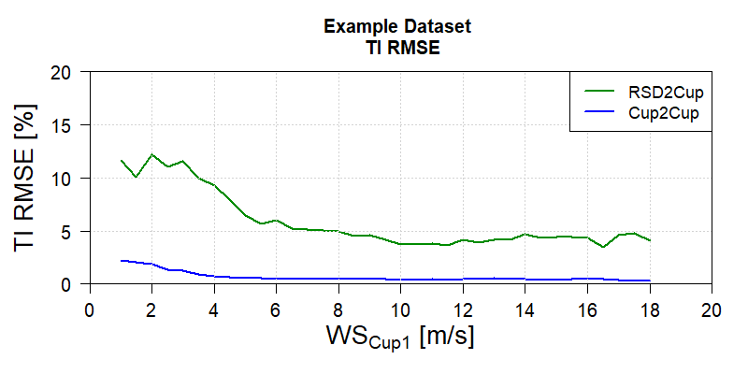

Figure 8 Root Mean Square Error (RMSE) for the Example Dataset

It is helpful to analyse MBE and RMSE together because they illustrate different, yet complementary, information about TI measurement comparisons. MBE depicts the closeness to the truth on average, and RMSE represents the average closeness of the results to each other and to the truth. For instance, in a dataset of TI error, half of the data are above the mean and half of the data are below the mean. In this case, the dataset is highly accurate on average (i.e., MBE = 0), but the spread of the data indicates noticeable statistical variability (i.e., RMSE > 0). Depending on how the analysis is presented and interpreted, these features in the data could lead to a higher uncertainty or lower confidence in the dataset overall.

The goal is to target both low MBE and low RMSE (i.e. adequate accuracy and high (adequate precision as shown in Figure 9c. Pillar 2 and 3, works towards evaluating whether any of the RSD TI adjustment methods achieves this goal.

|  |  |  |
| --- | --- | --- |
| truth  Figure 9a Low MBE and High RMSE | truth  Figure 9b High MBE and Low RMSE | truth  Figure 9c Low MBE, Low RMSE |

### Representative TI

In addition to quantifying the concurrent TI measurements’ accuracy and precision, the CFARS Site Suitability Subgroup is interested in understanding the magnitude of differences in Representative TI as it is used explicitly in making decisions regarding turbine suitability at a given site. Representative TI is defined as the value that marks the approximate 90th percentile of the TI distribution. In other words, there is a 90% probability that the measured TI will be less than or equal to the representative TI.

Returning to our example dataset, consider now the wind speed and TI data that has been binned by WS_Cup1. For each wind speed measurement (Cup1, Cup2 and RSD), we have WS_Avg, WS_Std, TI_Avg, and TI_Std. A sample binned data set is shown in the figure below.

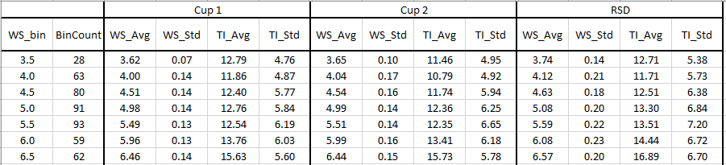

Table 1 Binned Results of the Example Dataset

From the binned data for an individual project, we can easily calculate **representative TI [IEC Ref],** by combining the binned TI_Avg and TI_Std data using:

|  |  |
| --- | --- |
|  | (4) |

where i is the wind speed bin.

Representative TI can be defined in this way as the turbulence intensity measurements within each wind speed bin are assumed to be normally distributed.

Figure 10 below shows the representative TI curves for the three wind speed measurements from the example dataset (Cup1, Cup2, RSD). These results show that the two cup anemometers measure very similar representative TI, while the lidar reports a higher representative TI across all wind speed bins. Since the data are from the same site and the dataset is concurrent, we can conclude that the measured representative TI is dependent on wind speed measurement device. It is important to calculate and evaluate representative TI across wind speeds because it is one of the direct inputs to loads models.

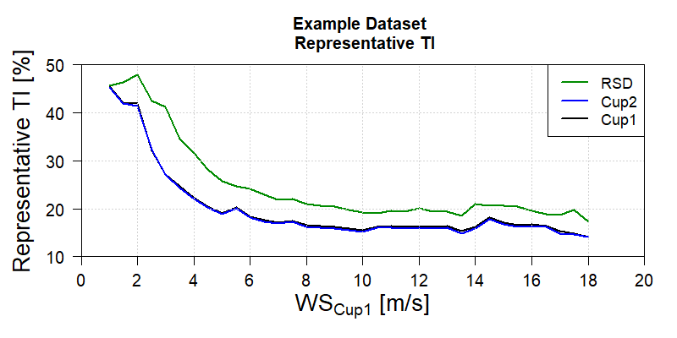

Figure 10 Representative TI Curves for Cup1, Cup2, and RSD for the Example Dataset

In addition, it is important to evaluate the difference in concurrent cup and RSD representative TI curves. Figure 11 below shows the difference between the representative TI value in each bin for the example dataset, again using Cup1 as the reference measurement.

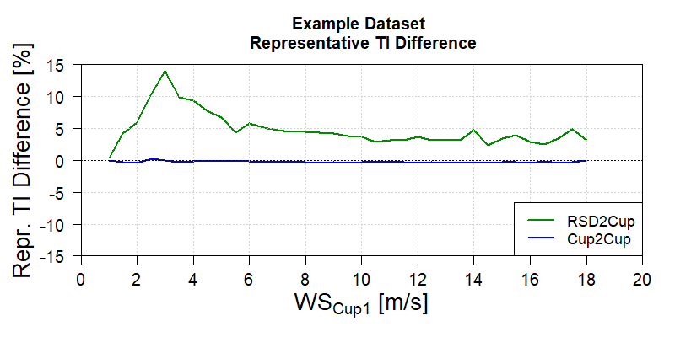

Figure 11 Representative TI Difference for the Example Dataset

## Benchmarking Results

### Aggregated TI MBE

For the comprehensive results of the benchmarking exercise, all 35 datasets compiled by the CFARS Site Suitability subgroup were leveraged to understand the *magnitude* of concurrent TI measurements’ MBE (i.e., difference or accuracy), and RMSE (i.e., precision or repeatability) and the dependence of these metrics on sensor type. Each project has an associated TI MBE curve for the Cup2Cup comparison, and all but six projects have an associated TI MBE curve for the RSD2Cup comparison.

Figure 12 below shows the TI MBE curve for each project as individual lines in the light color, and the binned average TI MBE across the entire CFARS dataset (i.e., **Aggregated TI MBE**) in the darker color. The example dataset represents just one of the individual light colored lines. Because not all projects have data for every wind speed bin, the project count included in the average for the aggregated result varies by wind speed. In other words, the Aggregated TI MBE is calculated as the average across all projects *with available data in that bin*.

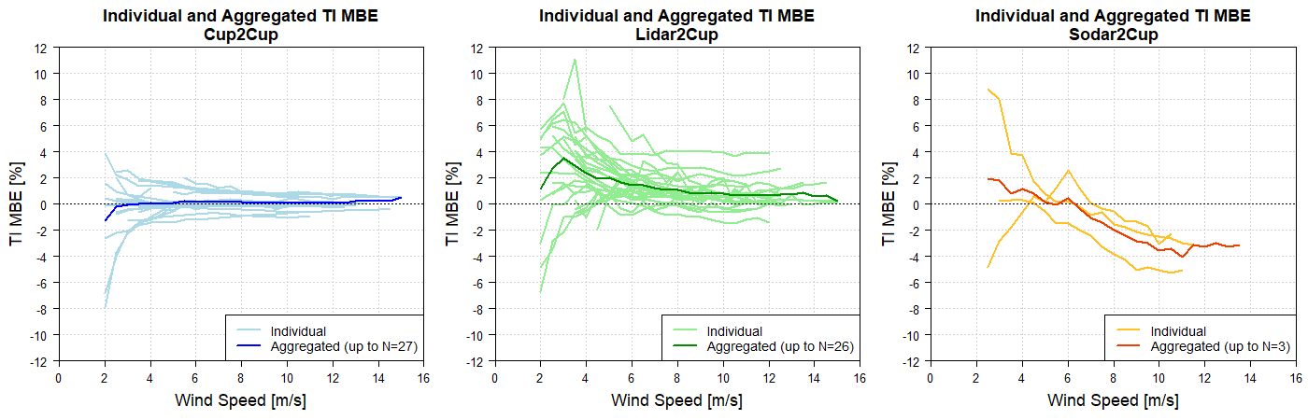

Figure 12 Individual Project and Aggregated TI MBE for Cup2Cup, Lidar2Cup, and Sodar2Cup[6]

In Figure 13, the same aggregated results as above are shown, now on the same axis. This plot shows the first *summary of key result from the benchmarking excercise*.

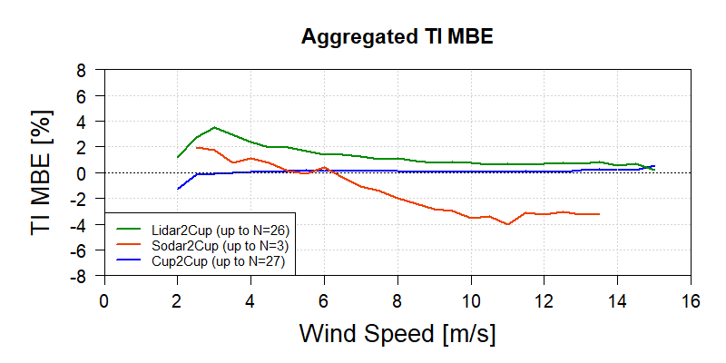

Figure 13 Aggregated TI MBE for Cup2Cup, Lidar2Cup, and Sodar2Cup4

Focusing on the more important wind speed bins for energy capture, 4-12 m/s, the aggregated Cup2Cup MBE is near-zero at 0.04-0.20% across the wind speed range (Table 2). Because the result is consistently positive, this means Cup2 slightly overestimates the TI compared to Cup1. For the full set of aggregated results by wind speed bin, see Table 1 in appendix.

|  |  |  |  |
| --- | --- | --- | --- |
| Range of Aggregated TI MBE for 4-12 m/s | | | |
|  | Cup2Cup | Lidar2Cup | Sodar2Cup |
| Min | 0.04 | 0.65 | -4.03 |
| Max | 0.20 | 2.40 | 1.13 |

*Table 2 Aggregated TI MBE for comparison at the 4-12 m/s bin range*

The Cup2Cup comparison includes mostly sites with two different cup anemometer models (23 out of 27), which results in anticipated anemometer to anemometer differences. The MBE is in some instances higher for individual projects (up to 2%) than the aggregate values as shown by the light blue lines in Figure 12.

The Lidar2Cup MBE is between 0.65-2.40% for the same wind speed range (demonstrating lidar TI overestimation), with a trend of improving accuracy as wind speeds increase. The Sodar2Cup MBE has a different trend, with positive MBE up to 1.13% for wind speeds less than 6 m/s and negative MBE up to -4.0% for wind speeds above 6 m/s.

It was expected that the MBE would be higher for the Lidar2Cup and Sodar2Cup comparisons due to inherent differences in measurement principles.

Both lidar and sodar tend to strongly overestimate TI at low wind speeds and sodar tends to strongly underestimate TI at high wind speeds. Tests were conducted with only 3 sodar (Triton) datasets, so strong conclusions cannot be drawn from the small sample size.

### Aggregated TI RMSE

Figures 14 and 15 are structured the same way as Figures 12 and 13 for TI MBE, but instead show the Individual and Aggregated TI RMSE metric.

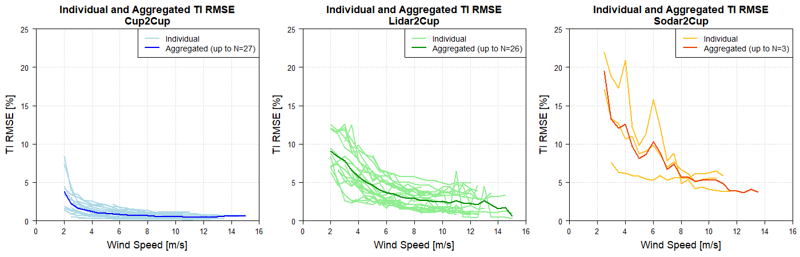

Figure 14 Individual Project and Aggregated TI RMSE for Cup2Cup, Lidar2Cup, and Sodar2Cup4

This plot shows the second key result from the benchmarking.

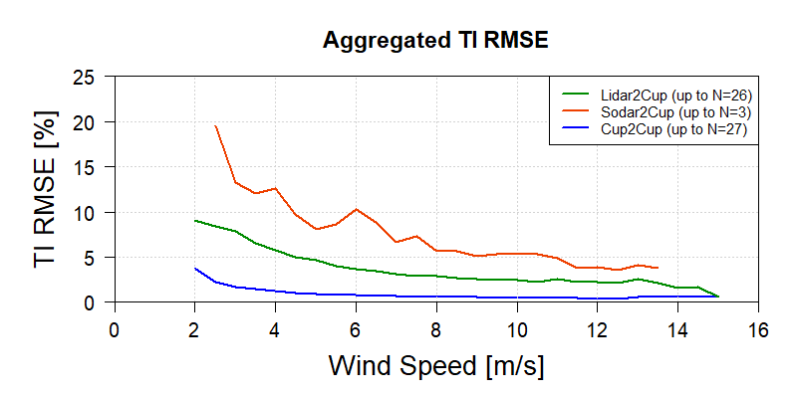

Figure 15 Aggregated TI RMSE for Cup2Cup, Lidar2Cup, and Sodar2Cup4

Again focusing on the wind speed range 4-12 m/s, the aggregated Cup2Cup RMSE result is again quite low (favorable precision) at 0.43-1.23% across the wind speed range. The Lidar2Cup RMSE is between 2.21-5.77% for the same wind speed range, and the Sodar2Cup RMSE is between 3.85-12.59%. All comparisons have a trend of improving precision as wind speeds increase.

|  |  |  |  |
| --- | --- | --- | --- |
| Range of Aggregated TI RMSE for 4-12 m/s | | | |
|  | Cup2Cup | Lidar2Cup | Sodar2Cup |
| Min | 0.43 | 2.21 | 3.85 |
| Max | 1.23 | 5.77 | 12.59 |

*Table 3 Aggregated TI RMSE for comparison at the 4-12 m/s bin range*

### Representative TI

Figure 16 and Figure 17 below show the representative TI results, now aggregated across all projects.

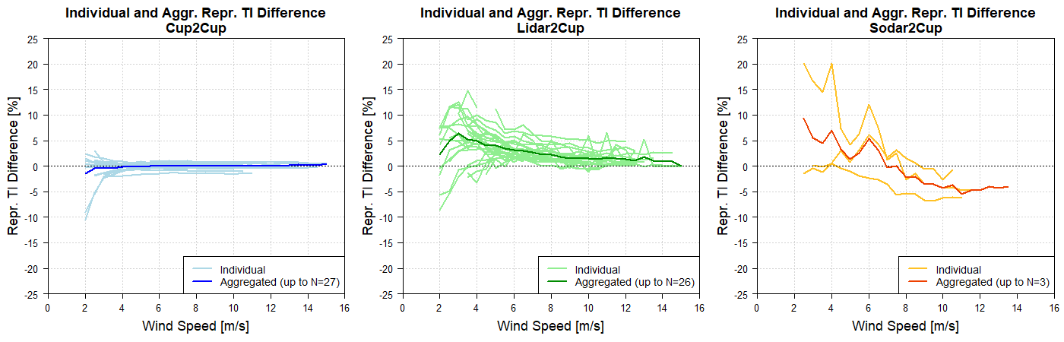

Figure 16 Individual Project and Aggregated Representative TI for Cup2Cup, Lidar2Cup, and Sodar2Cup4

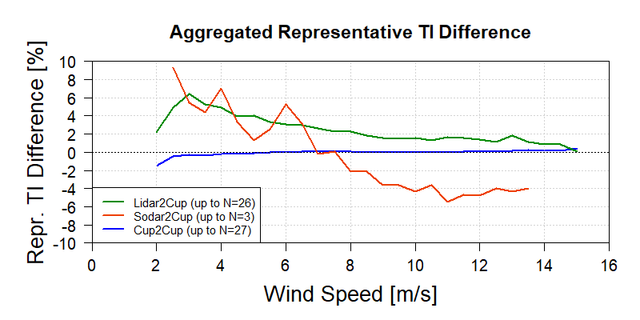

Figure 17 Aggregated Representative TI Difference for Cup2Cup, Lidar2Cup, and Sodar2Cup4

Within wind speed range 4-12 m/s, Cup2Cup aggregated representative TI difference ranges from -0.18 to 0.10 percent while aggregated representative TI difference for Lidar2Cup and Sodar to cup exhibit larger differences (Table 4). The Lidar2Cup aggregated representative TI difference is positive across all wind speed bins while the Sodar2Cup aggregated representative TI difference switches from positive to negative as wind speed surpasses 7 m/s.

|  |  |  |  |
| --- | --- | --- | --- |
| Range of Aggregated Representative TI Difference for 4-12 m/s | | | |
|  | Cup2Cup | Lidar2Cup | Sodar2Cup |
| Min | -0.18 | 1.30 | -5.43 |
| Max | 0.10 | 4.92 | 7.06 |

*Table 4 Aggregated Representative TI Difference for comparison at the 4-12 m/s bin range*

In addition to benchmarking, it is critical to contextualize these results. What magnitude difference in representative TI translates to differences in loads output or IEC class designation? These are the questions that will be addressed in Pillar 2 and 3 of this research initiative.

The change in ‘the representative ambient turbulence standard deviation’ [IEC 61400-1 Edition 4] (representative TI) associated with changing from one IEC turbulence subclass to another could represent a difference of up to 20 % of Representative TI. This is a very high threshold and not an acceptable level of bias for turbine load assessment. Therefore, IEC subclasses could act as a very coarse guideline to ‘reject’ certain high levels of bias but are too coarse to support acceptance.

## Conclusions & Next Steps, Further Work…

From the results presented in this white paper, the difference between RSD TI and cup TI is significantly larger (using all three metrics) than the difference for two cup anemometers on the same meteorological mast. INSERT MAG OF DIFFERENCE TEXT. These results 1) assess and document the current status of measurement discrepancies and 2) suggest that It is productive to develop a robust method (or methods) for the adjustment of RSD TI such that the difference between RSD and cup TI is sufficiently small to allow the use of adjusted RSD TI as an input to site suitability analyses.

IEC subclasses could act as a very course guideline to ‘reject’ certain high levels of bias but are too coarse to support acceptance.

In recent years wind turbines and their operational setup are very tightly aligned to the specific site conditions and specifications. This includes operational mode (e.g. power curve), lifetime assumptions, etc. This approach aims to utilise the turbine (load) envelope as much as possible for the obvious technical and commercial benefits. Therefore, any minor change in uncertainty or bias in the TI (and representative TI) would lead to a different operating regime and consequently different Annual Energy Production, failure rates, Levelised Cost of Energy, etc.

It is thought that the impact of terrain (flow) complexity and horizontal separation between RSD and meteorological mast will have an impact on the results.

Pillar 2 and 3 will enable the definition of the evaluation framework, however it is expected that the framework will be device specific and site climatic conditions specific. The key parameters for consideration are the TI and representative TI and a non-subjective measure of site climatic conditions (to enable the accurate characterisation and grouping of sites).

# References

Pending

# Appendix 1

The tables below provide the Aggregated TI MBE, RMSE, and Representative TI results.

Table 1 Aggregated TI MBE Results

|  |  |  |  |  |  |  |
| --- | --- | --- | --- | --- | --- | --- |
| **Wind Speed Bin** | **Cup2Cup** | | **Lidar2Cup** | | **Sodar2Cup** | |
| **Project Count** | **Aggregated TI MBE** | **Project Count** | **Aggregated TI MBE** | **Project Count** | **Aggregated TI MBE** |
| **[m/s]** | **[-]** | **[%]** | **[-]** | **[%]** | **[-]** | **[%]** |
| 2.0 | 9 | -1.25 | 10 | 1.19 | -- | -- |
| 2.5 | 15 | -0.18 | 14 | 2.75 | 2 | 1.97 |
| 3.0 | 18 | -0.08 | 16 | 3.52 | 3 | 1.78 |
| 3.5 | 24 | 0.00 | 23 | 2.96 | 3 | 0.79 |
| 4.0 | 24 | 0.06 | 23 | 2.40 | 3 | 1.13 |
| 4.5 | 24 | 0.04 | 23 | 1.93 | 3 | 0.80 |
| 5.0 | 25 | 0.11 | 24 | 1.98 | 3 | 0.14 |
| 5.5 | 27 | 0.20 | 26 | 1.69 | 3 | -0.04 |
| 6.0 | 27 | 0.15 | 26 | 1.41 | 3 | 0.42 |
| 6.5 | 27 | 0.16 | 26 | 1.40 | 3 | -0.32 |
| 7.0 | 26 | 0.16 | 25 | 1.25 | 3 | -1.06 |
| 7.5 | 25 | 0.15 | 24 | 1.06 | 3 | -1.42 |
| 8.0 | 26 | 0.15 | 25 | 1.11 | 3 | -2.00 |
| 8.5 | 25 | 0.07 | 24 | 0.88 | 3 | -2.43 |
| 9.0 | 23 | 0.08 | 22 | 0.79 | 3 | -2.84 |
| 9.5 | 23 | 0.05 | 22 | 0.86 | 3 | -2.96 |
| 10.0 | 23 | 0.05 | 22 | 0.78 | 3 | -3.53 |
| 10.5 | 22 | 0.06 | 21 | 0.65 | 3 | -3.39 |
| 11.0 | 20 | 0.06 | 20 | 0.68 | 2 | -4.03 |
| 11.5 | 16 | 0.11 | 17 | 0.65 | 1 | -3.13 |
| 12.0 | 16 | 0.08 | 16 | 0.69 | 1 | -3.26 |
| 12.5 | 12 | 0.08 | 11 | 0.76 | 1 | -3.00 |
| 13.0 | 6 | 0.21 | 5 | 0.71 | 1 | -3.28 |
| 13.5 | 5 | 0.26 | 4 | 0.84 | 1 | -3.16 |
| 14.0 | 3 | 0.22 | 3 | 0.59 | -- | -- |
| 14.5 | 3 | 0.21 | 3 | 0.67 | -- | -- |
| 15.0 | 2 | 0.54 | 2 | 0.21 | -- | -- |

Table 2 Aggregated TI RMSE Results

|  |  |  |  |  |  |  |
| --- | --- | --- | --- | --- | --- | --- |
| **Wind Speed Bin** | **Cup2Cup** | | **Lidar2Cup** | | **Sodar2Cup** | |
| **Project Count** | **Aggregated TI MBE** | **Project Count** | **Aggregated TI MBE** | **Project Count** | **Aggregated TI MBE** |
| **[m/s]** | **[-]** | **[%]** | **[-]** | **[%]** | **[-]** | **[%]** |
| 2.0 | 9 | 3.83 | 10 | 9.08 | -- | -- |
| 2.5 | 15 | 2.26 | 14 | 8.37 | 2 | 19.52 |
| 3.0 | 18 | 1.68 | 16 | 7.82 | 3 | 13.23 |
| 3.5 | 24 | 1.43 | 23 | 6.56 | 3 | 12.08 |
| 4.0 | 24 | 1.23 | 23 | 5.77 | 3 | 12.59 |
| 4.5 | 24 | 1.00 | 23 | 5.05 | 3 | 9.72 |
| 5.0 | 25 | 0.95 | 24 | 4.65 | 3 | 8.13 |
| 5.5 | 27 | 0.87 | 26 | 4.01 | 3 | 8.63 |
| 6.0 | 27 | 0.80 | 26 | 3.64 | 3 | 10.31 |
| 6.5 | 27 | 0.75 | 26 | 3.50 | 3 | 8.88 |
| 7.0 | 26 | 0.71 | 25 | 3.14 | 3 | 6.70 |
| 7.5 | 25 | 0.66 | 24 | 2.91 | 3 | 7.35 |
| 8.0 | 26 | 0.66 | 25 | 2.93 | 3 | 5.68 |
| 8.5 | 25 | 0.59 | 24 | 2.64 | 3 | 5.66 |
| 9.0 | 23 | 0.55 | 22 | 2.63 | 3 | 5.12 |
| 9.5 | 23 | 0.54 | 22 | 2.47 | 3 | 5.32 |
| 10.0 | 23 | 0.53 | 22 | 2.52 | 3 | 5.29 |
| 10.5 | 22 | 0.51 | 21 | 2.30 | 3 | 5.33 |
| 11.0 | 20 | 0.47 | 20 | 2.61 | 2 | 4.84 |
| 11.5 | 16 | 0.47 | 17 | 2.31 | 1 | 3.85 |
| 12.0 | 16 | 0.43 | 16 | 2.21 | 1 | 3.91 |
| 12.5 | 12 | 0.43 | 11 | 2.11 | 1 | 3.63 |
| 13.0 | 6 | 0.55 | 5 | 2.6 | 1 | 4.11 |
| 13.5 | 5 | 0.58 | 4 | 2.09 | 1 | 3.76 |
| 14.0 | 3 | 0.62 | 3 | 1.57 | -- | -- |
| 14.5 | 3 | 0.60 | 3 | 1.69 | -- | -- |
| 15.0 | 2 | 0.64 | 2 | 0.62 | -- | -- |

Table 3 Aggregated Representative TI Difference Results

|  |  |  |  |  |  |  |
| --- | --- | --- | --- | --- | --- | --- |
| **Wind Speed Bin** | **Cup2Cup** | | **Lidar2Cup** | | **Sodar2Cup** | |
| **Project Count** | **Aggregated Repr TI Diff** | **Project Count** | **Aggregated Repr TI Diff** | **Project Count** | **Aggregated Repr TI Diff** |
| **[m/s]** | **[-]** | **[%]** | **[-]** | **[%]** | **[-]** | **[%]** |
| 2.0 | 9 | -1.49 | 10 | 2.23 | -- | -- |
| 2.5 | 15 | -0.42 | 14 | 4.91 | 2 | 9.35 |
| 3.0 | 18 | -0.29 | 16 | 6.42 | 3 | 5.46 |
| 3.5 | 24 | -0.37 | 23 | 5.30 | 3 | 4.42 |
| 4.0 | 24 | -0.18 | 23 | 4.92 | 3 | 7.06 |
| 4.5 | 24 | -0.18 | 23 | 3.98 | 3 | 3.31 |
| 5.0 | 25 | -0.08 | 24 | 4.07 | 3 | 1.31 |
| 5.5 | 27 | 0.03 | 26 | 3.38 | 3 | 2.55 |
| 6.0 | 27 | -0.01 | 26 | 3.10 | 3 | 5.31 |
| 6.5 | 27 | 0.06 | 26 | 2.98 | 3 | 3.12 |
| 7.0 | 26 | 0.05 | 25 | 2.67 | 3 | -0.20 |
| 7.5 | 25 | 0.04 | 24 | 2.27 | 3 | 0.06 |
| 8.0 | 26 | 0.10 | 25 | 2.31 | 3 | -2.15 |
| 8.5 | 25 | -0.02 | 24 | 1.83 | 3 | -2.12 |
| 9.0 | 23 | 0.01 | 22 | 1.56 | 3 | -3.61 |
| 9.5 | 23 | -0.03 | 22 | 1.50 | 3 | -3.59 |
| 10.0 | 23 | 0.03 | 22 | 1.55 | 3 | -4.37 |
| 10.5 | 22 | 0.03 | 21 | 1.30 | 3 | -3.66 |
| 11.0 | 20 | 0.00 | 20 | 1.62 | 2 | -5.43 |
| 11.5 | 16 | 0.05 | 17 | 1.58 | 1 | -4.71 |
| 12.0 | 16 | 0.04 | 16 | 1.39 | 1 | -4.80 |
| 12.5 | 12 | 0.09 | 11 | 1.12 | 1 | -3.97 |
| 13.0 | 6 | 0.20 | 5 | 1.87 | 1 | -4.33 |
| 13.5 | 5 | 0.25 | 4 | 1.13 | 1 | -3.93 |
| 14.0 | 3 | 0.20 | 3 | 0.89 | -- | -- |
| 14.5 | 3 | 0.16 | 3 | 0.86 | -- | -- |
| 15.0 | 2 | 0.46 | 2 | 0.09 | -- | -- |

1. Standalone means there is no onsite meteorological mast
2. Standalone means there is no onsite meteorological mast
3. While it is not tested as part of this work, it is posited that, if adjustment methods for RSD TI can be shown to be sufficiently accurate for site suitability assessments, it is likely that the same methods will be sufficiently accurate for energy yield assessments.
4. One of the outcomes of this work will be the definition of the acceptance criteria for use of TI measurements from RSDs for the purposes of site suitability analysis.
5. The classification of sites is likely subjective and a different, data-based, approach to site classification will be used in the next stages (Pillar 2 and Pillar 3) of this work.
6. Note that there are only 3 sodar datasets, all for a single sodar model (Triton). Given the small sample size, caution should be exercised when drawing conclusions for this subset of the data.